Title: The Effects of Temperature and Music on Working Memory

Group Members: Natasha Kramer, Nicholas Davis, Saffra Parks, Valissa Davis, Ramon Soto Alvarez

**Introduction**

Studies have assessed the relationship of working memory connected with music. However, to the best of our knowledge no study has been done that includes the effects of high temperature and music simultaneously on working memory. We chose this idea to answer the question of how the difference in temperature, specifically heat, as well as the presence of music will affect the working memory of college aged students. So for our experiment our research question is: Do the interaction of high temperature and music have a significant impact on short-term working memory for college-aged students?

**What are the factors of interest?**

The factors in our research are the following:

**Factor 1:** Room Temperature

**Factor 2:** Music

**Level 1:** Classical music vs. No music

**Level 2:** Warmer temperature in room vs. standard temperature in room

**Response variable:** Memory game(s) to recollect the time in the controlled environment with above factors and levels

**What are the null and alternative hypotheses?**

Heat Factor:

Ho: µheat = µno heat

Ha: at least one of the population means is different (µheat ≠ µno heat )

Music Factor:

Ho: µmusic = µno music

Ha: at least one of the population means is different (µmusic ≠ µno heat )

Interaction:

Ho: There is no interaction between heat and music.

Ha: There is an interaction between heat and music.

**Data Collection**

**Randomization:** Each student that is willing to participate will be included in the study. They will be put into one of the four controlled rooms based on which room is available at the time the participant is available.

**Controlling:** Our control factor would be the number of people per group. We want to insure that there is the same number of subjects per group. As well as the four different room types with the conditions each of them have (music with heat, music no heat, no music and no heat, and no music with heat).

**Treatments:** The four treatment combinations are as follows

(1) classical music with standard room temperature room

(2) classical music with warmer temperature rating room

(3) no music with standard room temperature room

(4) no music with warmer temperature rating room

**Response**: A working memory task of a list of 12, random, three-letter nonsense words (examples can include WKD, SJE, SIC, and OJF). The response will then be calculated by how many letter combinations are remembered after a period of 45 seconds.

**Sample Size:** A minimum sample size of 15 students for each of the four treatment combinations will be taken, for a total of 60 participants in the study.

**After Designing it, how did it go?** Overall the experiment was carried out as planned. Each participant signed a consent form and was able to complete the tasks asked of them.

**Survey and Human Subjects**

1. **If human subjects are used, how will they be used?**

Human subjects will be used as participants in our experiment on short-term working memory.

**(2) Draft a survey with the words you will say to each subject when introducing yourself, giving instructions and asking questions.**

Survey will be attached on a different document.

**(3) If you are using human subjects, then you need to submit approval from the university using the following website:**

The approval application was submitted and approved on 5/15/18.

**Descriptive Statistics**

**Graphical Descriptive Statistics: Boxplots**

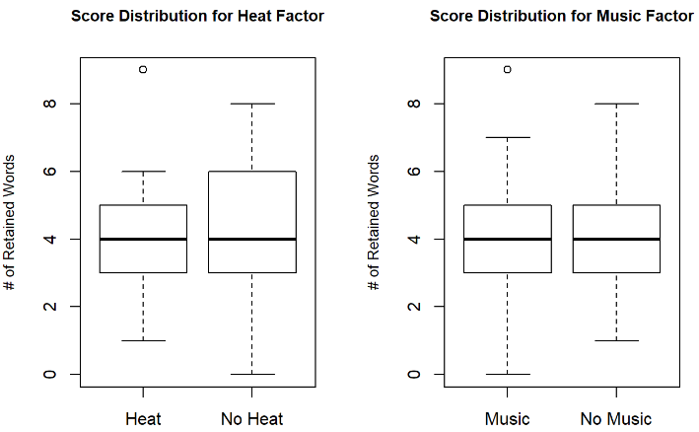

The boxplot set on the rights, the students that were tested with and without heat also had an average score of 4. The spread here is also interesting, students that were tested without heat performed the best and the worst, while that students with heat scored with in the 1-6 range. We wondered what could be the cause of the variability in the without heat group.

Based on the boxplot set on the left, it would appear that students that were tested with music, and students that were tested without music had the same average score of 4. It is interesting to note the spread though, there was some students in the without music group that scored around an 8, which was the highest score. While some students in the with group got a score of 0. We thought the classical music played would have a positive effect on memory.

Overall, According to all boxplots above, we can see that there is not much difference in the median scores between the different groups. Because of this we anticipate that the results of the ANOVA to be not statistically significant. The box plots show a similar distribution among all of the different groups, this is a good indicative that the assumption of equal variance is going to be fulfilled.

**Interaction Plots**

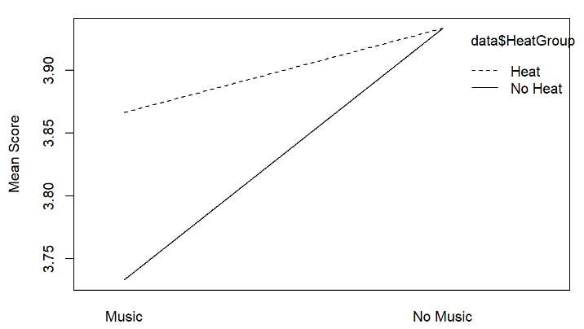

There appears to be a higher mean for those who participated in rooms with no music than those with music for both room controls of temperature difference (heat and no heat).

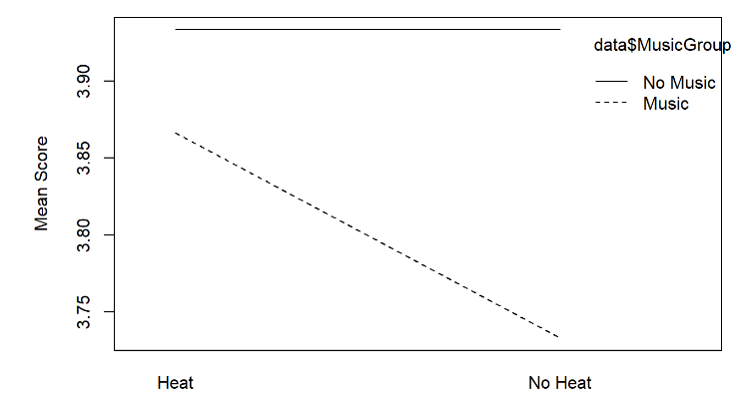

There appears to be no difference in those rooms of heat and no heat that also had no music. However those with music and no heat had a lower mean than those with heat and music.

**Means Plots**

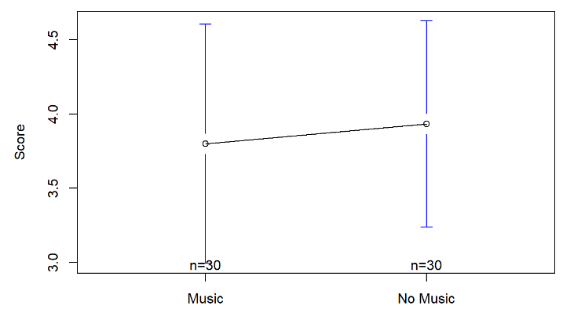

It would appear there is a higher mean in the group of students that performed without music.

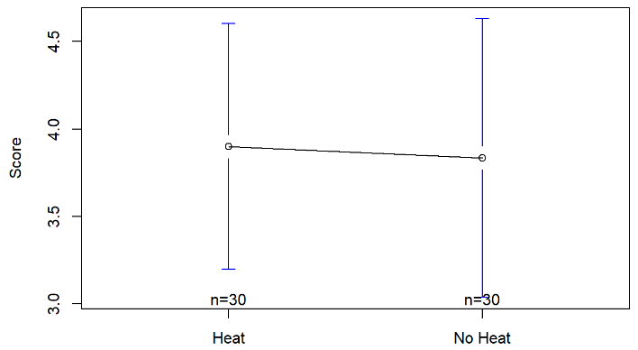

It would appear there is a higher mean in the group of students that performed with heat.

**Numerical Descriptive Statistics:**

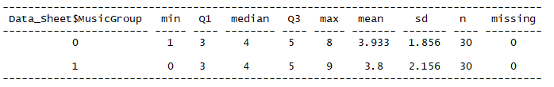

Above in the favstats table, for the factor music group (0 = with no music, 1 = with music) in comparison to the score factor we are able to see that the minimum score for those who had no music playing had a score of 0, a maximum of 8, a mean of 3.933, and a standard deviation of 1.856. However for those that had music playing in the room there was a minimum score of 0, a maximum of 9, a mean of 3.8 and a standard deviation of 2.156.

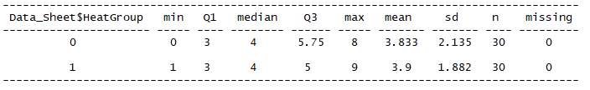

Above in the favstats table, for the factore heat group (0 = with no heat, 1 = with heat) in comparison to the score factor we are able to see the minimum score for those with heat not present in the room score a minimum of 0, a maximum of 8, a mean of 3.833, and a standard deviation of 2.135. The participants who were in rooms with heat had a minimum score of 1, a maximum score of 9, a mean of 3.9 and a standard deviation of 1.882.

**“Tell a story” based on what you see in your descriptive statistics:**

Based on the multiple tests ran for descriptive statistics we can assume that there will be no statistical significance between the groups of heat and music, heat and no music, no heat and music, and no heat and no music.

**Inferential Statistics**

**Checking Requirements:**

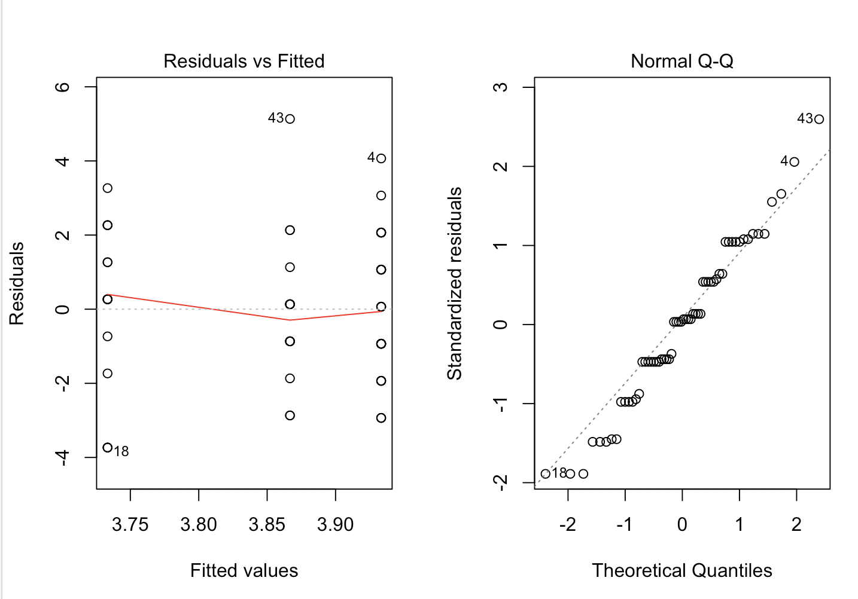

It would appear that the variance on the Residuals plot are mostly constant, although the red means line is not quite straight. Although not perfect, the Q-Q plot shows that the residuals are normally distributed. Thus, the requirements for a two-way ANOVA are met, and the results are trustworthy.

**ANOVA table**

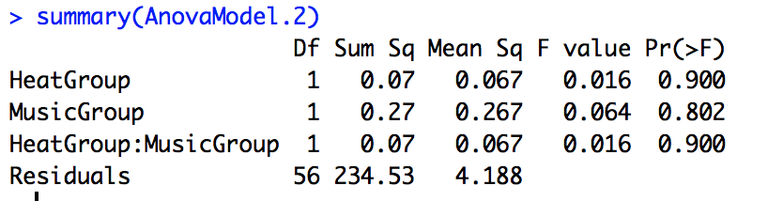

ANOVA table descriptions are based on the ANOVA table interactions.

***df* =** 1/56

***SS* =** 0.07

***MS* =** 0.067

***f-statistic*=** 0.016

***p-value* =** 0.900

***Decision rule (level of significance):*** Alpha = 0.05

**Any mean differences or mean treatment combinations that stand out?**

As we could see in the box plots and the results from the ANOVA test, there is no statistically significant mean differences. In other words, according to our results the study suggests heat or music affect short memory retention. A multiple comparisons test could be done in order to confirm our results, but it’s not necessary as the results are very clear in suggesting there is no difference in means.

**Conclusion**

**General Conclusion of your results based on decision rule:**

At the conclusion of our experiment we conclude that there is significant difference between those who had a test of working memory in a setting with heat and music. Now this is also concluded because our p-value is higher that 0.005, so we reject our null hypothesis and say that there is enough evidence to conclude that there is an interaction between the heat group and the music groups.

Another conclusion is based on the p-values from our heat and music groups. These values were also high so we can also reject the null hypotheses for the alternative hypothesis and say that there is sufficient evidence to conclude that at least one of the means differ.

**Why do you think you got the results you did?**

Given all of our requirement testing we believe we got the results of non-significance because of its general normality. When looking at our boxplots we were able to assume this, and after the testing through the ANOVA tables we were able to conclude that to be true - that there was no significant difference between those with heat and those with music influences.

**What would you have done differently?**

Concluding our experiment, we decided it would be better for us to use R or another device to randomly assign participants into rooms rather than assigning them based on convenience. Perhaps also having the demographic survey given right after the consent form was signed rather than waiting till the end of the study could help us in our randomization.

**Any follow up studies that you would have done?**

After further research into working memory articles we found that the average recall time for short term memory is about twenty seconds. Perhaps if given more time we would like to do an experiment where the recall time between seeing the words and being able to recall them differed in times. For example, one control could be immediately after seeing them, another could be twenty seconds, another could be forty five seconds, then see if there is any significant difference from recall time.

References

Carlson, S., Rama, P., Artchkov, D., & Linnankoski, I. (1997). Effects of music and white noise

on working memory performance in monkeys. *NeuroReport, 8*(13), 2853-2856. Retrieved

from: https://www.ncbi.nlm.nih.gov/pubmed/9376518

Kang, Y., Williams, L. E., Clark, M. S., Gray, J. R., & Bargh, J. A. (2011). Physical temperature

effects on trust behavior: The role of insula. *Social Cognitive and Affective Neuroscience,*

*6*(4), 507-515. doi: 10.1093/scan/nsq077

Musliu, A., Berisha, B., Latifi, D. (2017). The impact of music in memory. *European Journal of*

*Social Sciences Education and Research, 10*(2), 222-227. doi: 10.26417/ejser.v10i2.